**Front Matter**

Title Interfacial-Redox-Induced Tuning of Superconductivity in YBa2Cu3O7-δ

Short Title: Interfacial Tuning of Superconductivity in YBCO

**Authors**

Peyton D. Murray,1ξ Dustin A. Gilbert,2ξ Alexander J. Grutter,2 Brian J. Kirby,2

David Hernandez-Maldonado,3 Maria Varela,3 Zachary E. Brubaker,1,4 Rajesh V. Chopdekar,5,6 Valentin Taufour,1 Rena J. Zieve,1 Jason R. Jeffries,7 Elke Arenholz,6 Yayoi Takamura,5

Julie A. Borchers,2 Kai Liu1,8*

**Affiliations**

1Physics Department, University of California, Davis, CA 95616, USA.

2NIST Center for Neutron Research, National Institute of Standards and Technology, Gaithersburg, MD 20899, USA.

3Universidad Complutense de Madrid, Madrid 28040, Spain.

4Materials Science Division,Lawrence Livermore National Laboratory, Livermore, CA 94550, USA.

5Department of Materials Science and Engineering, University of California, Davis, CA 95616, USA.

6Advanced Light Source, Lawrence Berkeley National Laboratory, Berkeley, CA 94720, USA.

7Physics Division,Lawrence Livermore National Laboratory, Livermore, CA 94550, USA.

8Physics Department, Georgetown University, Washington, DC 20057, USA.

* Corresponding author: [Kai.Liu@georgetown.edu](mailto:Kai.Liu@georgetown.edu)

ξ These authors contributed equally to this work.

**Abstract**

Solid state ionic approaches for modifying ion distributions in getter/oxide heterostructures offer exciting potentials to control material properties. We report a scalable approach allowing for total control of the superconducting transition in films of optimally doped YBa2Cu3O7-δ (YBCO) via a chemically-driven ionic migration mechanism. Using a thin Gd capping layer of up to 20 nm deposited onto 100 nm thick epitaxial YBCO films, oxygen is found to leach from deep within the YBCO. Progressive reduction of the superconducting transition is observed, with complete suppression possible for a sufficiently thick Gd layer. These effects arise from the combined impact of redox-driven electron doping and modification of the YBCO microstructure due to oxygen migration and depletion. This work demonstrates an effective approach for tuning the superconductivity in oxides, extending the viability of ionic control of superconductivity to the quasi-bulk regime.

**MAIN TEXT**

**Introduction**

Many of the properties of the high-temperature copper oxide superconductors are strongly influenced by charge doping (*1*, *2*). The ability to control the doping level in these materials is not only essential for the development of experimental platforms for correlated electron physics, but also important for multifunctional device applications. While traditionally the doping level is fixed during synthesis via chemical substitution or post-growth annealing (*3*–*6*), a number of recent approaches have demonstrated on-demand control of the doping level. By leveraging electrolytic double layer techniques, gating experiments (*7*, *8*) on RBa2Cu3O7-δ (R=Y, Nd) thin films have achieved control over the Cu-site doping level, which determines the dominant electronic order, by introducing oxygen vacancies into the film under electric fields. In these materials, O2- ions can migrate under the influence of an externally applied electric field to eventually escape through the film surface, resulting in the formation of oxygen vacancies. To maintain charge neutrality, electrons are returned to the Cu ions within the film, resulting in a reduction in average Cu valence and reducing the hole concentration of the oxide. These interfacial effects have profound impact on the electronic order in these materials, and point to the efficacy of using oxygen migration and vacancy formation to manipulate the properties of the cuprate superconductors. Recently, another solid state approach of magneto-ionic control of interface magnetism has been demonstrated in a number of systems, (*9*–*16*) utilizing the oxygen ion/vacancy transport across the metal/oxide interface. For example, we have shown effective manipulation of ionic distributions in oxide thin films by using a getter Gd capping layer (*13*–*16*). Leveraging the reactivity of Gd, these capping layers can extract oxygen from an adjacent oxide film, with the level of oxygen depletion controlled by the thickness of the Gd and the ion mobility in the oxide, often at room-temperature. Interestingly, this ionic approach offers the possibility to manipulate the material properties into the bulk of the oxide films, well beyond the Thomas-Fermi screening length of the metal/oxide interface region (*15*, *16*).

In this work, we demonstrate interfacial-redox-induced tuning of superconductivity throughout the entire thickness of 100 nm thick YBa2Cu3O7-δ (YBCO) films. YBCO is a prototypical example of the high- cuprates, with crystal structure and electronic ordering sensitive to oxygen stoichiometry. Combined with its high ionic conductivity (*17*, *18*), these properties make YBCO an ideal candidate for explorations of ionic control. We find that Gd capping layers of up to 20 nm thickness deposited on 100 nm thick YBCO films can dramatically alter the oxygen distribution throughout the underlying film in the as-deposited state, without the need for a post-deposition annealing step. As the Gd layer thickness () is increased, the YBCO layer becomes progressively more oxygen deficient, demonstrating how appropriate tuning of can precisely control the remaining oxygen content of the underlayer. The extraction of oxygen from the YBCO suppresses the and broadens the superconducting transition. Differences between the superconducting transitions observed in resistivity and magnetometry suggest the formation of a percolative network of oxygen deficient regions interspersed within the nominally stoichiometric YBCO. Both the electron doping and structural changes induced by Gd-driven oxygen migration contribute to the suppression of superconductivity. These results demonstrate an effective solid-state ionic means to tailor superconductivity in cuprates and other systems, including the potential to use an electric field to control superconductivity.

**Results**

Commercially available epitaxial films of pulsed-laser-deposited c-axis oriented YBa2Cu3O7-δ (100 nm) grown on (001) SrTiO3 (STO) substrates were used for this study (*19*). The high-symmetry STO substrate (cubic, lattice parameter of 3.905 Å) is known to yield YBCO films with 90° twinned domains (*20*), with up-to 2% tensile strain exerted at the interface due to lattice mismatch (*21*, *22*) (bulk lattice parameters of YBCO are *a* = 3.827 Å, *b* = 3.893 Å, and *c* = 11.699 Å (*23*)). While the strain is known to suppress , the films are expected to relax away from the substrate/film interface (*24*, *25*) and show near bulk-like superconducting behavior (*22*). The films were then sputter coated with Gd layers of varying thickness ( 3 nm, 7 nm, 20 nm) and an Au (5 nm) protective cap, with one witness sample of YBCO/STO kept in the as-grown state for comparison.

X-ray diffraction (XRD) scan of the as-grown film (Fig. 1A) shows only the family of peaks, corresponding to a lattice parameter of *c* =11.678 Å, similar to the bulk value of 11.699 Å (*23*). The slightly smaller *c*-axis lattice parameter is likely due to the tensile strain from the substrate (*26*). As is increased, a monotonic shift towards lower is observed in the YBCO diffraction peaks, indicating expansion in the *c*-axis, similar to those previously reported in other perovskite systems (*27*) as a signature of oxygen depletion. From the full widths at half maximum (FWHM’s) of the diffraction peaks, corrected for the instrument width, the crystallite size is determined to be 103 nm and 65 nm for the as-grown and 7 nm sample, respectively. The former is consistent with the entire YBCO film thickness for the as-grown sample, while the latter indicates that for a 7 nm Gd capping layer, some structural change and reduction of the crystallite size have occurred. However, for the 20 nm sample, a significant shift and broadening of the peaks is observed, indicating further *c*-axis expansion as well as modification of the crystalline structure. The much broader peak width corresponds to a crystallite size of 14 nm, much smaller than the YBCO film thickness or the crystallite size of the 7 nm sample, indicating significant changes in the film crystallinity.

In addition to the out-of-plane direction, the in-plane structure of the films was probed using reciprocal space maps (RSMs) taken near the STO substrate reflection (Figs. 1B-E, G-J). Coordinates of the RSMs identify the *h* (*x*-axis) and *l* (*y*-axis) Miller indices relative to the STO substrate lattice parameters. When grown on cubic STO substrate, nominally orthorhombic YBCO is expected to form a twinned crystal structure, resulting in a splitting of the in-plane Bragg reflections (*21*). For each sample, the RSM shows a bright, sharp substrate peak (Figs. 1B-E), while the streaking of the substrate peak in the nm and 7 nm samples is likely due to some inhomogeneities in the substrate. Each of the nm, 3 nm, and 7 nm samples also shows a lower-intensity, broadened YBCO peak near ; for this peak is absent (Fig. 1G-J). The RSMs integrated along the *h*-index show the evolution of the substrate and film peaks across the different samples (Figs. 1F and 1K, respectively). Owing to the nearly identical in-plane lattice parameters, two closely spaced Bragg reflections are expected from the and YBCO crystal planes; however, only one broad peak is observed in the as-grown YBCO (Fig. 1G). The center of this peak is displaced towards more negative values of than the STO peak, indicating that these films are relaxed in-plane before Gd capping layers are deposited. As is increased, the YBCO film peak broadens along the direction and shifts to lower , consistent with an expansion in the *c*-axis lattice parameter discussed above.

The effects of Gd deposition on the YBCO superconducting properties were investigated by magnetometry, as well as resistivity measurements in the van der Paw geometry. For magnetometry measurements, each sample was zero-field cooled to 5 K and measured on heating from 5 K to 100 K in a 1 mT magnetic field. Temperature dependence of the magnetization of the as-grown YBCO film shows a sharp superconducting transition at K (Fig. 2), which is typical of YBCO films grown on STO substrates (*22*). Below , the magnetic flux is expelled from the superconducting YBCO due to the Meissner effect. Accompanying the magnetic transition is a precipitous drop in resistivity to zero, further confirming the superconducting transition. With increasing Gd capping layer thickness, the Meissner effect shows a reduction of to 62 K for and 36 K for , along with a broadened transition, and a complete suppression of superconductivity for nm. In contrast, resistivity measurements initially show only a small reduction for nm. However, for nm and nm the resistive superconducting transition is completely suppressed, with no apparent transition down to the lowest measured temperature (5 K).

While transport measurement probes a contiguous superconducting path, magnetometry is sensitive to the Meissner effect with contributions from the entire sample. The different temperature dependence observed in magnetometry and resistivity therefore reflects the inhomogeneities in the YBCO film, with magnetometry probing superconducting regions with any , and resistivity measurement being most sensitive to regions of the film with the highest – so long as a superconducting path is maintained. The observed transitions can be explained by the presence of an oxygen-deficient phase with lower , stabilized alongside the optimally doped YBCO phase. For the nm sample most of the film possesses the as-made YBCO structure and the optimal stoichiometry of YBa2Cu3O7-δ; thus a contiguous path exists through the optimally doped phase, and the resistive transition is observed close to the of the as-grown film, even though the sample-averaged Meissner effect shows a much lower *Tc* with a more gradual transition. For the nm sample, an even more broadened transition is observed in the magnetometry, but no complete suppression of resistivity is observed. Therefore, this sample contains some oxygen deficient regions which are still superconducting at lower , as seen in magnetometry, but these phases are below the percolation threshold to form a contiguous superconducting path, as evidenced by the absence of a transition in the resistance. Finally, for the thickest nm sample the absence of a transition in either the resistance or magnetization suggests few, if any, regions undergo superconducting transition in the sample. The distinctly different superconducting properties of the oxygen deficient phases may be the result of structural changes or electron doping, both of which are consequences of the oxygen leaching.

The Gd capping layer is expected to extract oxygen from the YBCO, resulting in the structural changes that were observed in XRD patterns. Cross-sectional high-angle annular dark field scanning transmission electron microscopy (HAADF-STEM) images of the as-grown film at the STO/YBCO interface show flat, epitaxial c-axis oriented YBCO growth consistent with XRD patterns (Fig. 3A). The layered structure of YBa2Cu3O7-δ is well resolved, as illustrated in a zoomed-in view of the STO/YBCO interface shown in Fig. 3A inset (right half of the inset). The CuO chain is manifested as a dark contrast region between bright contrast perovskite blocks of BaO-CuO2-Y-CuO2-BaO. A number of CuO stacking faults, which disrupt the YBCO epitaxy, are found in the imaged region of Fig. 3A, highlighted by red dashed lines. In the Gd (3 nm) / YBCO sample, the lateral extent of these stacking faults increases as the film becomes increasingly oxygen deficient, as highlighted by the red dashed lines in Fig. 3B. An example is illustrated in Fig. 3B inset, where a CuO stacking fault is seen as a wider, dark-contrast region in the middle of bright contrast perovskite blocks. The number of stacking faults increases even further for the Gd (20 nm)/YBCO sample, but these defects are more fragmented than those observed for , as shown in Fig. 3C. Effectively these defects “carve out” the epitaxial YBCO film into smaller crystallites, consistent with the aforementioned much reduced crystallite size extracted from XRD peak width. Examples of similar stacking faults have been previously reported in pulsed laser deposited films of YBCO (*28*–*30*), and attributed to the limited atomic diffusion range under typical PLD conditions. Double- or multiple-CuO stacking faults form different microstructural phases than optimally doped YBa2Cu3O7-δ (Y-123, with numbers denoting cation stoichiometry), e.g. Y-124 and Y-247. These defects directly alter the CuO chains, which act as charge reservoirs for superconductivity in the YBCO system. Accordingly, these types of defects affect the superconducting transition, and result in lowered critical temperatures as compared to Y-123 (*31*–*34*). These stacking faults point to the aggressive nature of the oxygen leaching effect, as the YBCO layers become increasingly disrupted when oxygen is removed from deep within the film, and suggest that changes to the microstructure are directly correlated with the suppression of superconductivity.

The extraction of oxygen was further probed by polarized neutron reflectometry (PNR), which provides a depth-resolved mapping of the nuclear scattering centers within the film. The converged depth profiles confirm that the nuclear scattering length density (SLD, ) of the as-grown film is similar to the calculated value for YBa2Cu3O7 of (Fig. 4A). With increasing the YBCO layer increases in thickness, in qualitative agreement with the unit cell expansion observed in XRD. Commensurate with the progressive increase in , the nuclear SLD decreases, particularly near the YBCO/Gd interface, consistent with the removal of oxygen from the YBCO (Figs. 4B-4C); furthermore, the oxygen-deficient layer goes deeper into the YBCO film as the Gd layer thickness is increased, as indicated by the deviation of the real part of *N* from that of the stoichiometric YBCO (grey lines). In addition to the real part of the nuclear profile, the Gd layer is explicitly identifiable by the imaginary component of its SLD, which corresponds to neutron absorption. Since Gd is the only significant neutron absorber present in this system, the location of the imaginary component of the nuclear SLD rules out the possibility of YBCO/Gd interdiffusion.

The PNR results are consistent with the extraction of oxygen from the YBCO, and fluorescence yield (FY) XAS measurements performed at the Cu *L*2,3-edges directly confirm a change in the Cu valence induced by the oxygen extraction. The XAS results show a shift in the absorption resonance to lower energies with increasing (Fig. 5). Similar spectral shifts reported in other oxygen-deficient perovskite systems (*35*, *36*) have been attributed to a decrease in the average Cu valence, the result of electrons returning to the Cu ions as oxygen is leached from the film. The shoulder around 933 eV in the as-grown YBCO spectra (marked with a black arrow), a feature characteristic of lower-valence ligand states present in CuO chains (*8*, *37*–*39*), is suppressed for YBCO coated with increasingly thicker Gd, confirming the loss of oxygen within the chains. A second resonance associated with the Cu+ valence state emerges at 934 eV for 7 nm and 20 nm; this absorption peak was previously reported in oxygen deficient bulk YBCO, and expected to be absent for samples with optimal oxygen stoichiometry (*38*). The bulk sensitivity of FY measurements (~70% X-ray transmission through 100 nm of YBCO at Cu-*L*2 resonance) infers that the observed oxygen depletion comes from ionic migration from deep within the film despite the interfacial origin of the leaching effect. The high ionic conductivity required for such long-range oxygen migration at room temperature is in agreement with previous reports (*17*, *18*). The known sensitivity of the YBCO superconductivity to the oxygen stoichiometry suggests that this ionic approach may therefore be used as an effective means to control the superconducting transition.

**Discussion**

Two different mechanisms may contribute to the suppression of superconductivity. The first mechanism is electron doping, as observed in XAS, where the more oxygen is stripped away by the adjacent Gd capping layer, the more the Cu valence state decreases. This electron doping effectively shifts the YBCO film from the optimally doped state, with maximum , back towards the electron-doped region of the global phase diagram, with a corresponding decrease in . Magnetometry shows that for =3 and 7 nm, the superconducting transition broadens across a range of temperatures, indicating regions with a distribution of coexist within the same film. The second mechanism involves the disruption to the film microstructure. The crystal structure of optimally doped YBCO contains both CuO2 planes – where superconductivity resides – and CuO chains, which act as doping centers for the planes. As oxygen is removed from the film, the chains become progressively more oxygen deficient (*18*), leading to more defects present in the YBCO film, as observed by STEM. The presence of double- and multiple-CuO stacking faults directly modifies these doping centers, locally forming separate phases with lower values of .

In summary, thin Gd capping layers deposited onto optimally doped YBCO thin films have been shown to remove oxygen from the underlying film via an interfacial redox reaction, with the extent dependent on capping layer thickness. This redox-induced oxygen migration, although initiated at the Gd/YBCO interface, results in a percolating oxygen deficient phase throughout the entire film thickness that does not support superconductivity. As measured in magnetometry and resistivity, the superconducting transition temperature is significantly reduced with increasing Gd thickness, and for a sufficiently thick capping layer of up to 20 nm, the transition is completely suppressed. Spectroscopic measurements reveal the loss of oxygen with the CuO chains as well as a decrease in the average Cu valence, indicating that oxygen leaching effectively acts to electron dope the YBCO and thus decreases . STEM images reveal the presence of defects associated with separate, oxygen-deficient phases, suggesting that both changes to the microstructure as well as a reduction in hole doping level may play roles in the suppression of superconductivity. Remarkably, the changes to the superconducting properties throughout the entire 100 nm thick YBCO films are induced by the migration of oxygen towards the YBCO/Gd interface, extending the viability of ionic control of superconductivity to the quasi-bulk regime. As ionic transport can be easily controlled by a bias voltage, our findings also show potential in electric field control of superconductivity in getter/oxide type of heterostructures.

**Materials and Methods**

**Film growth and characterization**

Commercially available 100 nm thick YBCO films grown on STO substrates were purchased from MTI Corporation for this experiment. The films, which were packaged and kept in a vacuum-sealed box prior to Gd deposition, were exposed to atmosphere for < 1 h before being transferred to a high vacuum environment at UCD; they were subsequently sputter-coated with Gd (3 nm, 7 nm, 20 nm) and a Au (5 nm) protective capping layer using Ar gas at Pa working pressure in a chamber with a base pressure of < Pa. XRD characterization, including both scans and reciprocal space maps, was performed on a X-ray diffractometer equipped with parallel beam optics and Cu monochromator. Polarized neutron reflectometry was measured at the NIST Center for Neutron Research on the PBR and MAGIK beamlines. The experiment used 5 Å neutrons, and were carried out at a temperature of 6 K. Fitting of the PNR data was performed using the Refl1d software package, following a Markov-chain Monte Carlo fitting algorithm (*40*). The calculated SLD was determined by the calculating the sum of the volume-scaled atomic scattering lengths. XAS measurements were performed at the Advanced Light Source on beamline 4.0.2 at room temperature in a grazing incidence (30°) geometry. Both fluorescence and electron yield (EY) modes were measured, but due to the capping layers no appreciable signal was measured in the EY mode. Magnetometry measurements were performed by first cooling the samples to 5 K in zero field; a field of 1 mT was then applied, and the magnetic moment was recorded as the sample was warmed up to 100 K. To reduce stray magnetic fields and trapped flux, the superconducting magnet was driven into the normal state before each measurement. The transition temperatures quoted from the magnetometry were acquired by taking the midpoint of the transitions. Resistivity was measured using a four-contact van der Pauw geometry. The excitation current used was 100 µA at a frequency of 173 Hz.

References

1. R. J. Cava, B. Batlogg, K. M. Rabe, E. A. Rietman, P. K. Gallagher, L. W. Rupp, Structural anomalies at the disappearance of superconductivity in Ba2YCu3O7−δ: Evidence for charge transfer from chains to planes. *Phys. C*. **156**, 523–527 (1988).

2. S. Blanco-Canosa, A. Frano, E. Schierle, J. Porras, T. Loew, M. Minola, M. Bluschke, E. Weschke, B. Keimer, M. Le Tacon, Resonant X-ray Scattering Study of Charge Density Wave Correlations in YBa2Cu3O6+x. *Phys. Rev. B*. **90**, 054513 (2014).

3. M. R. Presland, J. L. Tallon, R. G. Buckley, R. S. Liu, N. E. Flower, General trends in oxygen stoichiometry effects on Tc in Bi and Tl superconductors. *Phys. C*. **176**, 95–105 (1991).

4. P. A. Lee, N. Nagaosa, X.-G. Wen, Doping a Mott insulator: Physics of high-temperature superconductivity. *Rev. Mod. Phys.* **78**, 17–85 (2006).

5. W. A. Groen, D. M. de Leeuw, G. P. J. Geelen, Hole concentration and Tc in Bi2Sr2CuO6+δ. *Phys. C*. **165**, 305–307 (1990).

6. R. G. Humphreys, J. S. Satchell, N. G. Chew, J. A. Edwards, S. W. Goodyear, S. E. Blenkinsop, O. D. Dosser, A. G. Cullis, Physical vapour deposition techniques for the growth of YBa2Cu3O7 thin films. *Supercond. Sci. Technol.* **3**, 38–52 (1990).

7. A. M. Perez-Muñoz, P. Schio, R. Poloni, A. Fernandez-Martinez, A. Rivera-Calzada, J. C. Cezar, E. Salas-Colera, G. R. Castro, J. Kinney, C. Leon, J. Santamaria, J. Garcia-Barriocanal, A. M. Goldman, In operando evidence of deoxygenation in ionic liquid gating of YBa2Cu3O7-X. *Proc. Natl. Acad. Sci.* **114**, 215–220 (2017).

8. L. Zhang, S. Zeng, X. Yin, T. C. Asmara, P. Yang, K. Han, Y. Cao, W. Zhou, D. Wan, C. S. Tang, A. Rusydi, Ariando, T. Venkatesan, The Mechanism of Electrolyte Gating on High-Tc Cuprates: The Role of Oxygen Migration and Electrostatics. *ACS Nano*. **11**, 9950–9956 (2017).

9. U. Bauer, S. Emori, G. S. D. Beach, U. Bauer, S. Emori, G. S. D. Beach, Electric field control of domain wall propagation in Pt / Co / GdOx films Electric field control of domain wall propagation in Pt / Co / GdOx films. *Appl. Phys. Lett.* **192408**, 10–14 (2012).

10. U. Bauer, S. Emori, G. S. D. Beach, Voltage-controlled domain wall traps in ferromagnetic nanowires. *Nat. Nanotechnol.* **8**, 411–416 (2013).

11. C. Bi, Y. Liu, T. Newhouse-Illige, M. Xu, M. Rosales, J. W. Freeland, O. Mryasov, S. Zhang, S. G. E. Te Velthuis, W. G. Wang, Reversible control of Co magnetism by voltage-induced oxidation. *Phys. Rev. Lett.* **113**, 267202 (2014).

12. U. Bauer, L. Yao, A. J. Tan, P. Agrawal, S. Emori, H. L. Tuller, S. Van Dijken, G. S. D. D. Beach, Magneto-ionic control of interfacial magnetism. *Nat. Mater.* **14**, 174–181 (2015).

13. A. J. Grutter, D. A. Gilbert, U. S. Alaan, E. Arenholz, B. B. Maranville, J. A. Borchers, Y. Suzuki, K. Liu, B. J. Kirby, Reversible control of magnetism in La0.67Sr0.33MnO3 through chemically-induced oxygen migration. *Appl. Phys. Lett.* **108**, 082405 (2016).

14. D. A. Gilbert, J. Olamit, R. K. Dumas, B. J. Kirby, A. J. Grutter, B. B. Maranville, E. Arenholz, J. A. Borchers, K. Liu, Controllable positive exchange bias via redox-driven oxygen migration. *Nat. Commun.* **7**, 11050 (2016).

15. D. A. Gilbert, A. J. Grutter, E. Arenholz, K. Liu, B. J. Kirby, J. A. Borchers, B. B. Maranville, Structural and magnetic depth profiles of magneto-ionic heterostructures beyond the interface limit. *Nat. Commun.* **7**, 12264 (2016).

16. D. A. Gilbert, A. J. Grutter, P. D. Murray, R. V. Chopdekar, A. M. Kane, A. L. Ionin, M. S. Lee, S. R. Spurgeon, B. J. Kirby, B. B. Maranville, A. T. N’Diaye, A. Mehta, E. Arenholz, K. Liu, Y. Takamura, J. A. Borchers, Ionic tuning of cobaltites at the nanoscale. *Phys. Rev. Mater.* **2**, 104402 (2018).

17. G. J. Shen, C. C. Lam, J. C. L. Chow, S. T. Tang, Twin formation due to irradiation of energetic electron beam in high-temperature superconductors of In- and Sb-doped YBCO. *Phys. C*. **214**, 426–434 (1993).

18. J. H. Müller, W. Mertin, R. Gruehn, Oxygen mobility in YBa2Cu3O7-x: A TEM and HRTEM investigation. *Supercond. Sci. Technol.* **3**, 273–281 (1990).

19. M. Lorenz, H. Hochmuth, D. Matusch, M. Kusunoki, V. L. Svetchnikov, V. Riede, I. Stanca, G. Kastner, D. Hesse, High-quality Y-Ba-Cu-O thin films by PLD-ready for market applications. *IEEE Trans. Appiled Supercond.* **11**, 3209–3212 (2001).

20. J. M. Phillips, Substrate selection for high-temperature superconducting thin films. *J. Appl. Phys.* **79**, 1829–1848 (1996).

21. J. D. Budai, R. Feenstra, L. A. Boatner, X-ray study of in-plane epitaxy of YBa2Cu3Ox thin films. *Phys. Rev. B*. **39**, 12355–12358 (1989).

22. H. Y. Zhai, W. K. Chu, Effect of interfacial strain on critical temperature of YBa2Cu3O7-δ thin films. *Appl. Phys. Lett.* **76**, 3469–3471 (2000).

23. G. Calestani, C. Rizzoli, Crystal structure of the YBa2Cu3O7 superconductor by single-crystal X-ray diffraction. *Nature*. **328**, 606–607 (1987).

24. W. J. Lin, P. D. Hatton, F. Baudenbacher, J. Santiso, Observation of small interfacial strains in YBa2Cu3Ox sub-micron-thick films grown on SrTiO3 substrates. *Appl. Phys. Lett.* **72**, 2966–2968 (1998).

25. F. M. Granozio, F. Ricci, U. Scotti di Uccio, J. C. Villegier, Orthorhombic-tetragonal transition in twin-free (110) YBa2Cu3O7 films. *Phys. Rev. B*. **57**, 6–9 (1998).

26. C. Xie, J. I. Budnick, B. O. Wells, J. C. Woicik, Separation of the strain and finite size effect on the ferromagnetic properties of La0.5Sr0.5CoO3 thin films. *Appl. Phys. Lett.* **91**, 172509 (2007).

27. S. Miyoshi, J. O. Hong, K. Yashiro, A. Kaimai, Y. Nigara, K. Kawamura, T. Kawada, J. Mizusaki, Lattice expansion upon reduction of perovskite-type LaMnO3 with oxygen-deficit nonstoichiometry. *Solid State Ionics*. **161**, 209–217 (2003).

28. R. Ramesh, D. M. Hwang, T. Venkatesan, T. S. Ravi, L. Nazar, A. Inam, X. D. Wu, B. Dutta, G. Thomas, A. F. Marshall, T. H. Geballe, Direct Observation of Structural Defects in Laser-Deposited Superconducting Y-Ba-Cu-O Thin Films. *Science*. **247**, 57–59 (1990).

29. L. F. Fu, N. D. Browning, W. Ramadan, S. B. Ogale, D. C. Kundaliya, T. Venkatesan, Interface and defect structures in YBa2Cu3O7-δ and Nb:SrTiO3 heterojunction. *J. Phys. D. Appl. Phys.* **40**, 187–191 (2007).

30. R. Ramesh, D. M. Hwang, J. B. Barner, L. Nazar, T. S. Ravi, A. Inam, B. Dutta, X. D. Wu, T. Venkatesan, Defect structure of laser deposited Y-Ba-Cu-O thin films on single crystal MgO substrate. *J. Mater. Res.* **5**, 704–716 (1990).

31. R. J. Cava, B. Batlogg, R. B. van Dover, D. W. Murphy, S. Sunshine, T. Siegrist, J. P. Remeika, E. A. Rietman, S. Zahurak, G. P. Espinosa, Bulk Superconductivity at 91 K in Single-Phase Oxygen-Deficient Perovskite Ba2YCu3O9-δ. *Phys. Rev. Lett.* **58**, 1676–1679 (1987).

32. P. Bordet, C. Chaillout, J. Chenavas, J. Hodeau, Structure determination of the new high-temperature superconductor Y2Ba4Cu7O14+x. *Nature*. **334**, 596–596 (1988).

33. D. E. Morris, N. G. Asmar, J. Y. T. Wei, J. H. Nickel, R. L. Sid, J. S. Scott, J. E. Post, Synthesis and properties of the 2:4:7 superconductors R2Ba4Cu7O15-x (R=Y, Eu, Gd, Dy, Ho, Er). *Phys. Rev. B*. **40**, 11406–11409 (1989).

34. D. E. Morris, J. H. Nickel, J. Y. T. Wei, N. G. Asmar, J. S. Scott, U. M. Scheven, C. T. Hultgren, A. G. Markelz, J. E. Post, P. J. Heaney, D. R. Veblen, R. M. Hazen, Eight new high-temperature superconductors with the 1:2:4 structure. *Phys. Rev. B*. **39**, 7347–7350 (1989).

35. B. Li, R. V. Chopdekar, A. T. N’Diaye, A. Mehta, J. P. Byers, N. D. Browning, E. Arenholz, Y. Takamura, Tuning interfacial exchange interactions via electronic reconstruction in transition-metal oxide heterostructures. *Appl. Phys. Lett.* **109**, 152401 (2016).

36. N. Lu, P. Zhang, Q. Zhang, R. Qiao, Q. He, H. B. Li, Y. Wang, J. Guo, D. Zhang, Z. Duan, Z. Li, M. Wang, S. Yang, M. Yan, E. Arenholz, S. Zhou, W. Yang, L. Gu, C. W. Nan, J. Wu, Y. Tokura, P. Yu, Electric-field control of tri-state phase transformation with a selective dual-ion switch. *Nature*. **546**, 124–128 (2017).

37. C. T. Chen, L. H. Tjeng, J. Kwo, H. L. Kao, P. Rudolf, F. Sette, R. M. Fleming, Out-of-plane orbital characters of intrinsic and doped holes in La2-xSrxCuO4. *Phys. Rev. Lett.* **68**, 2543–2546 (1992).

38. N. Nücker, E. Pellegrin, P. Schweiss, J. Fink, S. L. Molodtsov, C. T. Simmons, G. Kaindl, W. Frentrup, A. Erb, G. Müller-Vogt, Site-specific and doping-dependent electronic structure of YBa2Cu3Ox probed by O 1s and Cu 2p x-ray-absorption spectroscopy. *Phys. Rev. B*. **51**, 8529–8542 (1995).

39. A. Bianconi, A. Congiu Castellano, M. De Santis, P. Delogu, A. Gargano, R. Giorgi, Localization of Cu 3d levels in the high Tc superconductor YBa2Cu3O~7 by Cu 2p X-ray photoelectron spectroscopy. *Solid State Commun.* **63**, 1135–1139 (1987).

40. B. J. Kirby, P. A. Kienzle, B. B. Maranville, N. F. Berk, J. Krycka, F. Heinrich, C. F. Majkrzak, Phase-sensitive specular neutron reflectometry for imaging the nanometer scale composition depth profile of thin-film materials. *Curr. Opin. Colloid Interface Sci.* **17**, 44–53 (2012).

**Acknowledgments:** This work has been supported by the NSF (DMR-1610060 and ECCS-1611424). Work at LLNL has been supported by the DOE (DE-AC52-07NA27344) and NSF (DMR-1609855). Use of the Advanced Light Source was supported by DOE Office of Science User Facility under Contract No. DE-AC02-05CH11231.

**Author contributions:** P.D.M., D.A.G. and K.L. coordinated the project. P.D.M. synthesized the samples, carried out structural analysis, and wrote a first draft of the manuscript. D.A.G., A.J.G., B.J.K, and J.B. performed PNR studies. D.A.G. and A.J.G. and E. A. carried out XAS measurements. D. H-M. and M.V. carried out electron microscopy studies. V. T. measured magnetometry. Z.E.B., J.R.J., and R. Z. carried out transport measurements. R.V.C. and Y.T. assisted with sample synthesis and RSM studies. All authors contributed to data analysis and manuscript revision. **Competing interests:** The authors declare no competing interests. **Data and materials availability:** Experimental data is available upon request.

**Figures**

**Fig 1**. **X-ray diffraction.** (**A**) XRD scan near the (002) YBCO peak measured with Cu radiation. Reciprocal space maps showing (**B-E**) the () STO substrate peak, (**G-J**) YBCO peak, indexed relative to the STO lattice parameters, and (**F, K**) -integrated RSMs for each sample.

**Figure 2**. **Superconducting transition.** Normalized magnetization (**A**) and resistivity (**B**) from 5 K to 100 K. The Gd (20 nm) sample has been omitted from (**B**), as no appreciable magnetic moment was detected in the temperature range measured (to within experimental noise). Transition width and as determined from magnetometry (**C**).

**Figure 3**. **STEM images.** Cross-sectional HAADF-STEM images of (**A**) the as-grown STO/YBCO interface with a magnified view of the substrate/film interface shown in the inset. The region shown in the inset is outside the field of view of the main image. The crystal structure is depicted with Cu, Ba, Y, Sr, and Ti atoms highlighted in yellow, red, blue, violet, and orange, respectively. (**B**) The YBCO/Gd interface of the Gd (3 nm) sample with a magnified view of the region highlighted by the black box shown in the inset. (**C**) Center of the YBCO layer in the Gd (20 nm) film, with a magnified view of the region indicated by the black box shown in the inset. Both insets in (**B**) and (**C**) contain vertically oriented CuO stacking faults in the middle, similar to those in (**A-C**) highlighted by dashed red lines.

**Figure 4**. **Polarized Neutron Reflectometry.** Real and imaginary components of the nuclear SLDs as a function of depth through the (**A**) as grown, (**B**) Gd (3 nm), (**C**) Gd (7 nm), and (**D**) Gd (20 nm) samples as measured by PNR. Grey region () corresponds to the substrate, with the approximate location of the YBCO, Gd, and Au layers given by the shaded regions for (). The nominal SLD of optimally doped YBa2Cu3O7-δ is shown by the grey line in each panel.

**Figure 5**. **X-ray Absorption Spectra.** Close-up view of the normalized absorption spectra as a function of incident X-ray photon energy near the Cu -edge, as measured in fluorescence yield mode. The full spectral range measured including the Cu -edge is shown in the inset, with the shaded region corresponding to the close-up view. The arrow marks the shoulder at 933 eV.

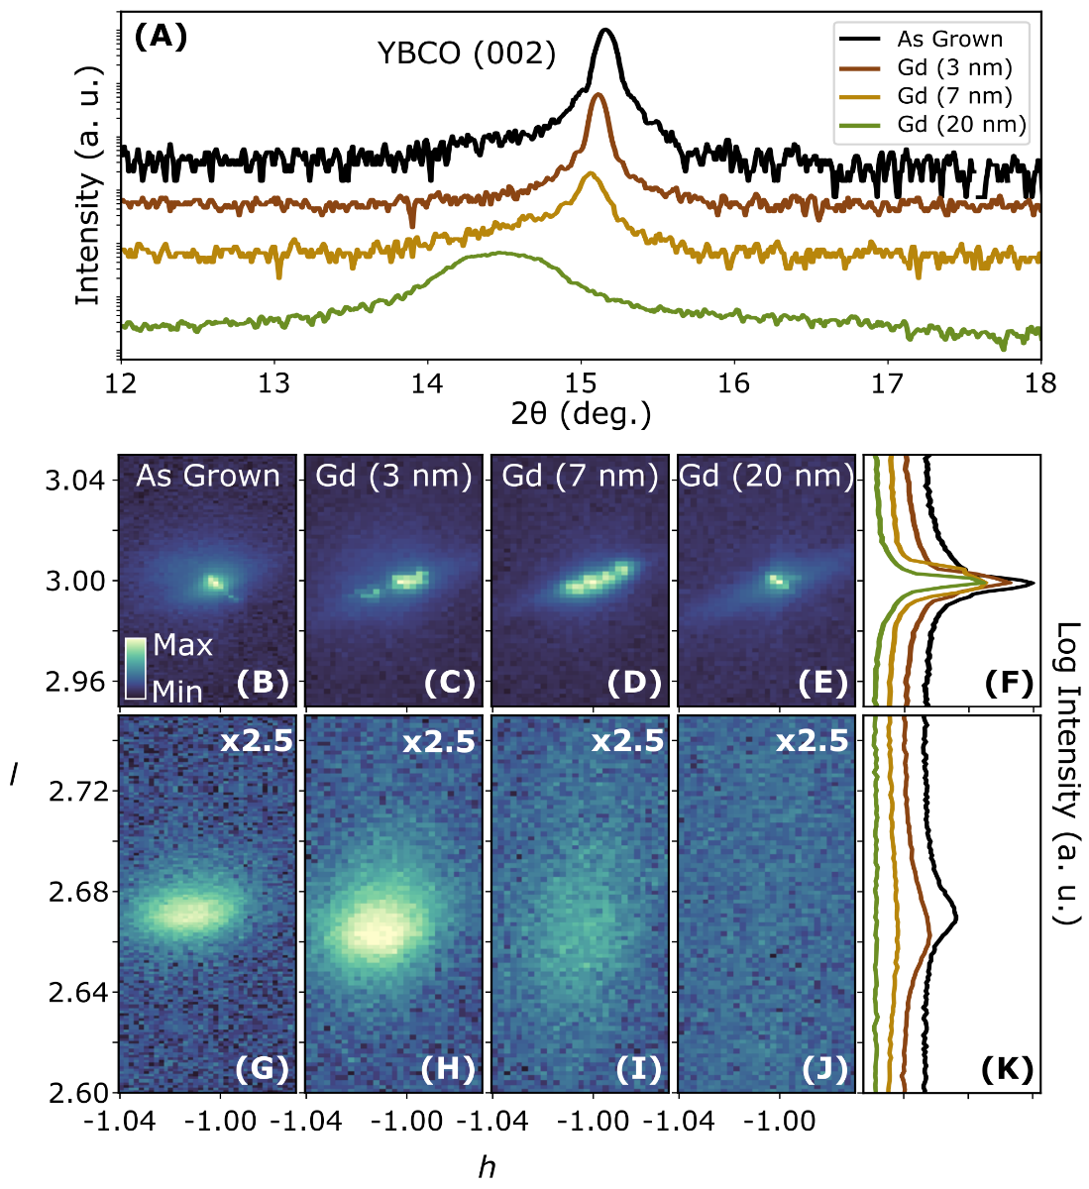

**Fig. 1**

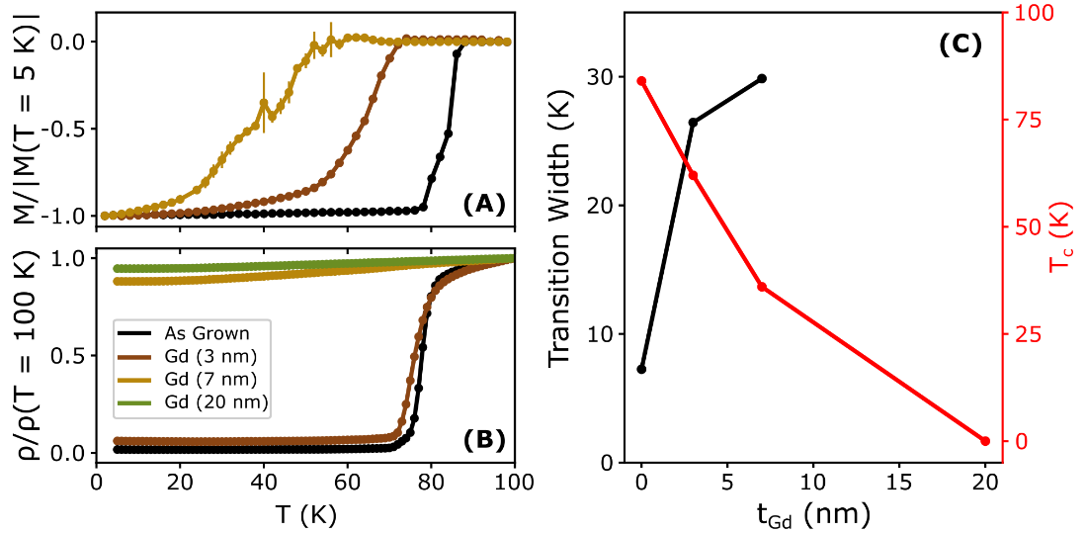

**Fig. 2**

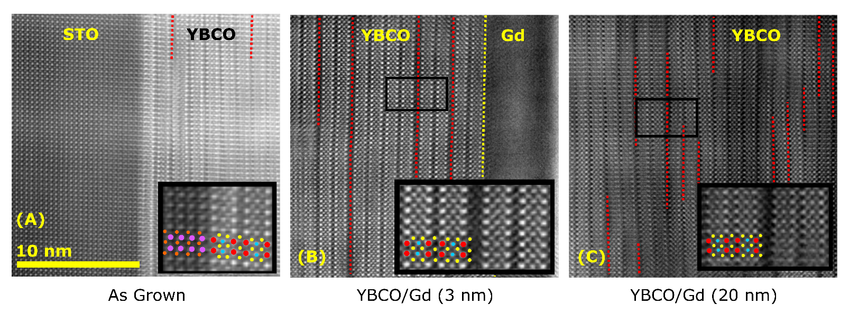

**Fig. 3**

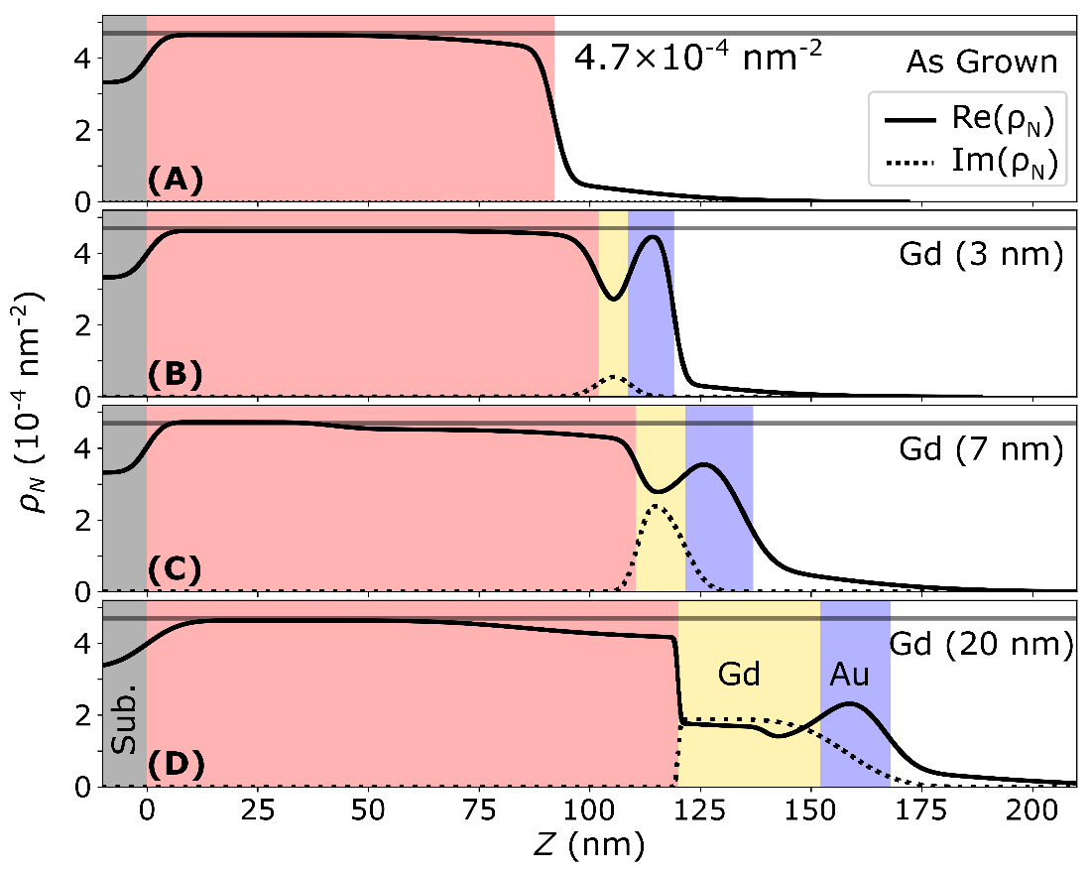

**Fig. 4**

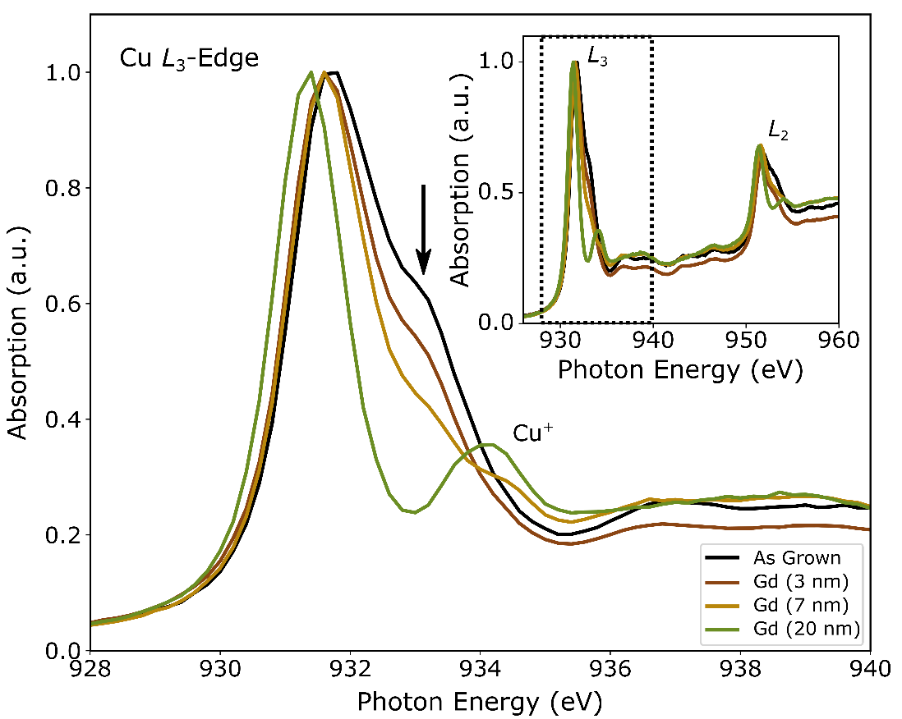

**Fig. 5**